

SQL STATEMENT FOR CUSTOMER OPERATION

ISAD251HK – NG SHU MING ARTHAS



[Date]

[Company name]

[Company address]

# StoryBoard

# Entity-Relationship (ER) Diagram

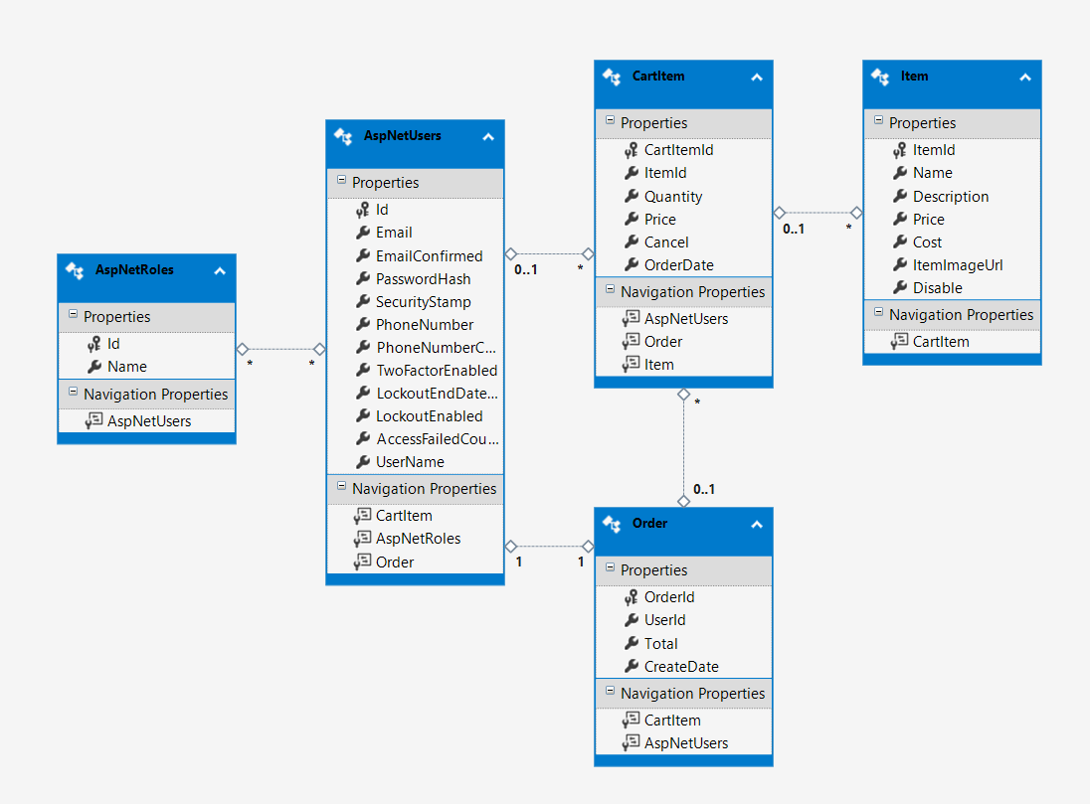

# UML Class Diagram

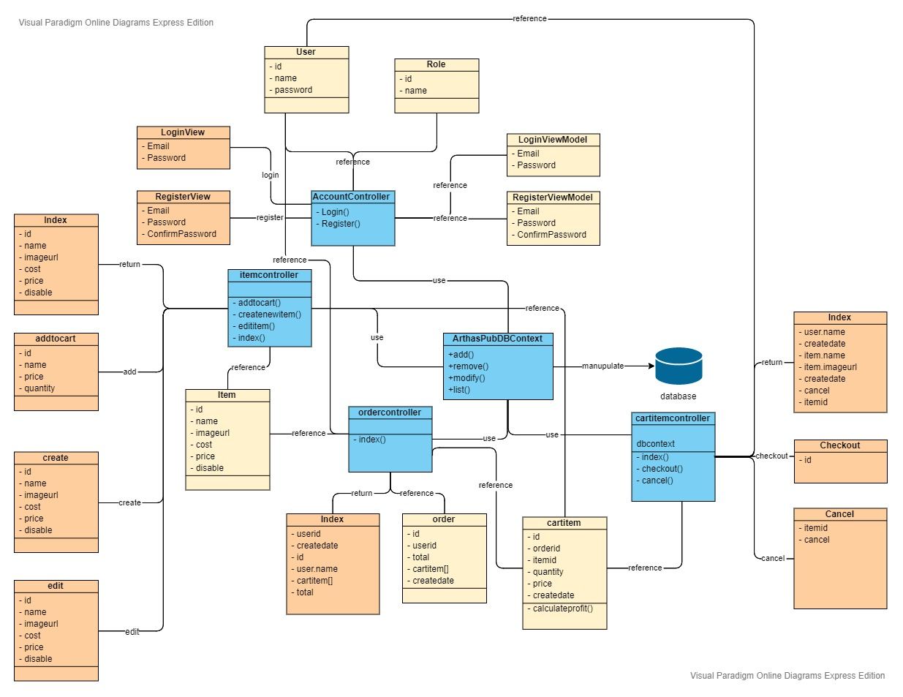

# Package installed

# 

# Document any settings and images.

# Provide evidence that you have tested your web application using the Web Accessbility Initiative (WAI) guidelines with a commentary about what you would change and why.

# Include a list of the feedback acquired from the Demo sessions indicating what you changed and what you would change if you had more time.

# Provide the URL’s for your API middleware, your hosted web pages and your GitHub repo.